Housing Investigation - Student Instructions
- Design a dream house in which you would like to live
  - First, make a list of all the rooms you wish to include
  - Make a draft plan including all necessary measurements*
- Redraw the draft of this plan to scale(e.g. 1cm represents 2 m [1:200])
- Calculate the area and perimeter of all rooms.
- Draw your house in Google Sketch up
- Make your house out of paper, ie. with the birds eye view and add the walls. It all must be to scale
- Using the Bunnings Kaboodle kitchen planner organise what your kitchen will look like and how much it will cost http://www.kaboodleplanner.com.au/UI/Pages/VPUI.htm
- Calculate how much it would cost to paint and carpet the whole house, use the Dulux Paint calculator to find out how much paint you will use. http://www.dulux.com.au/products/paint-calculator
You can buy either: 500mL = $7 4L tin of paint =$77.59 10L=$147.50

*For a personal challenge and bonus marks include irregular shapes (circles, compound shapes)

Some samples to give you inspiration. Please note that these have not been drawn to scale.
Sample 1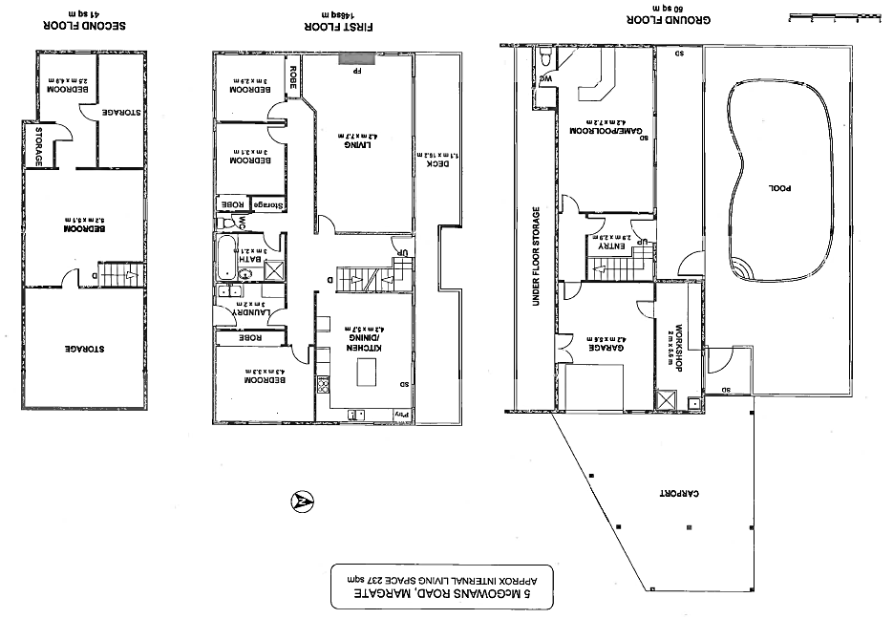

Sample 2 Sample 3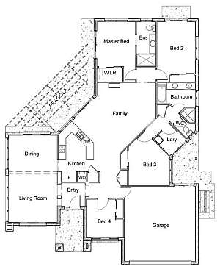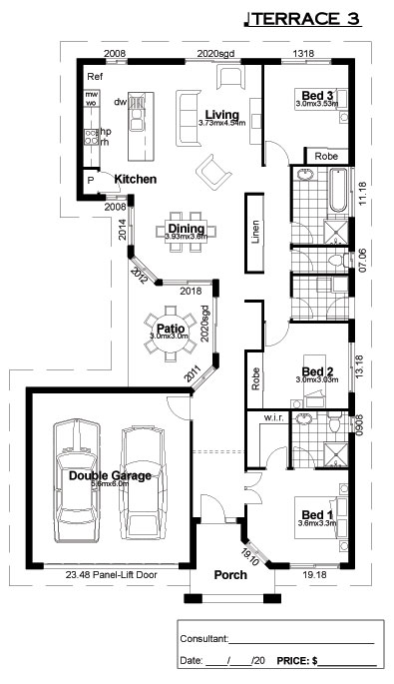
Sample 4
